**Snake**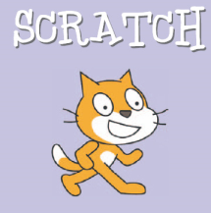

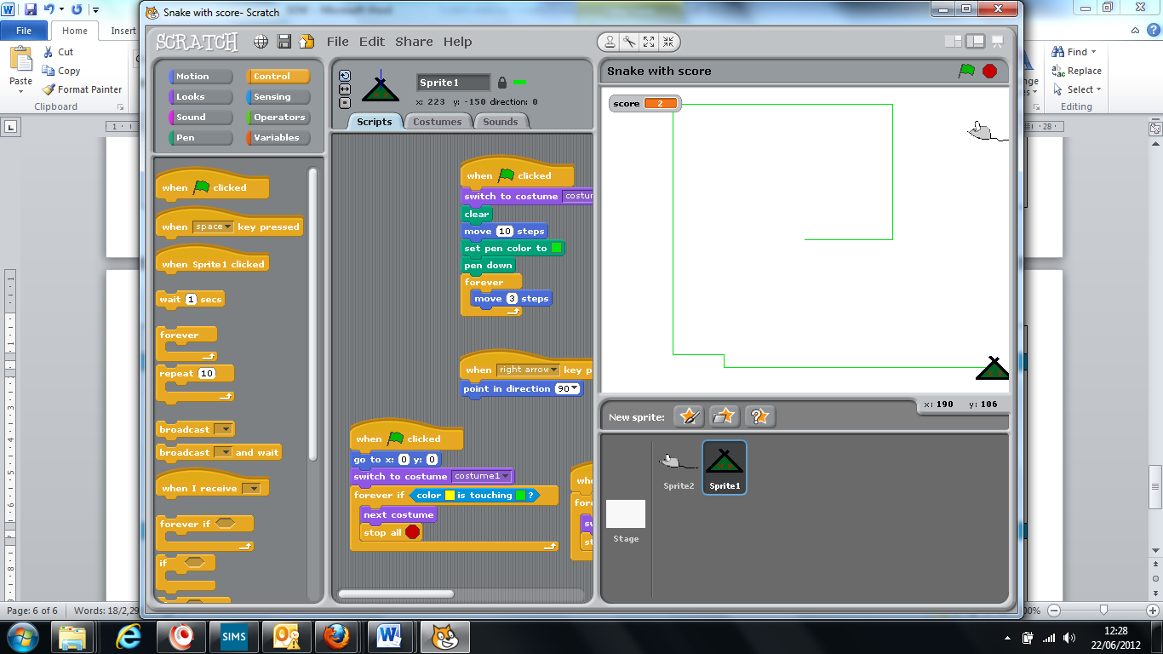In Scratch you can create a snake game by following these steps

**Objectives**

1. To understand how the pen tool works
2. To understand how to use colours in Scratch to make game

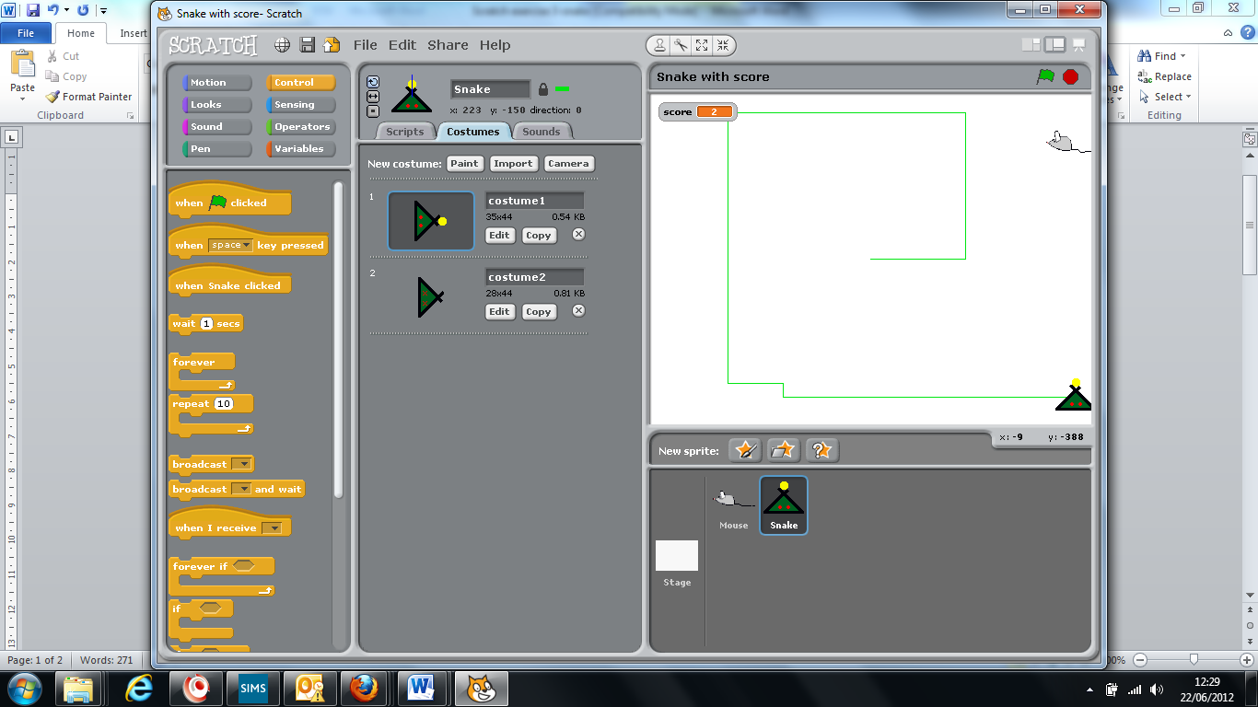**Step 1**: Create 2 Sprites

A mouse. Your snake will try and capture this.

 A snake. This is what you will control.

**WHEN YOU DRAW YOUR SNAKE IT IS CRUCIAL THAT YOU INCLUDE A YELLOW DOT AT THE FRONT. THIS WILL BE USED AS A SENSOR**

**Step 2**: controlling the snake

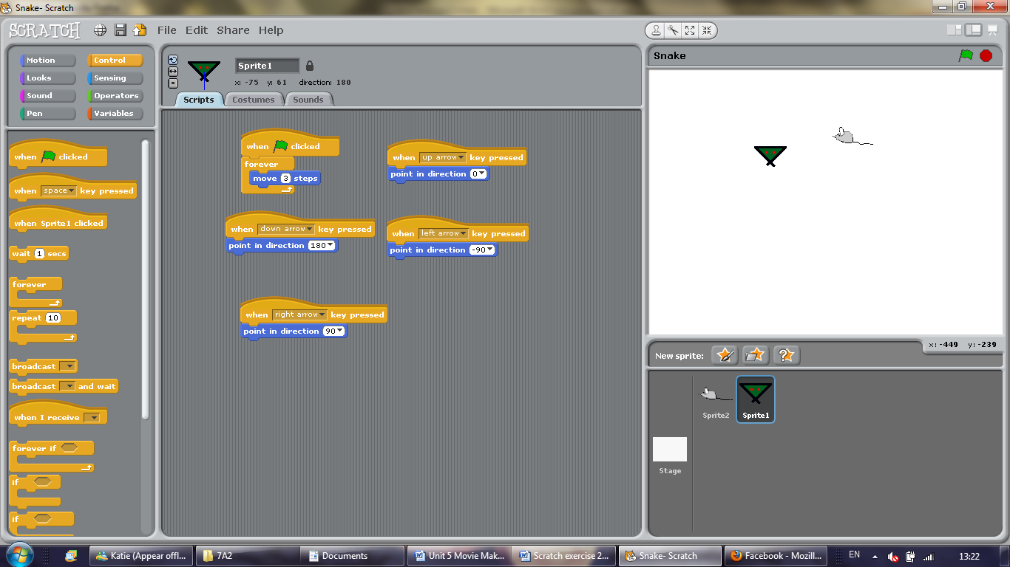You need to be able to control the snake using the up, down, left and right buttons. The snake must move automatically, as this will make it more similar to the real game.

Enter these sequences on your snake sprite

When the green flag is clicked the snake will automatically move forward 3 steps

The other controls identify when a button has been pressed and changes the direction of the sprite depending on what button has been pressed.

**Step 3:** What happens if the snake eats the mouse? **This must go on the mouse sprite**

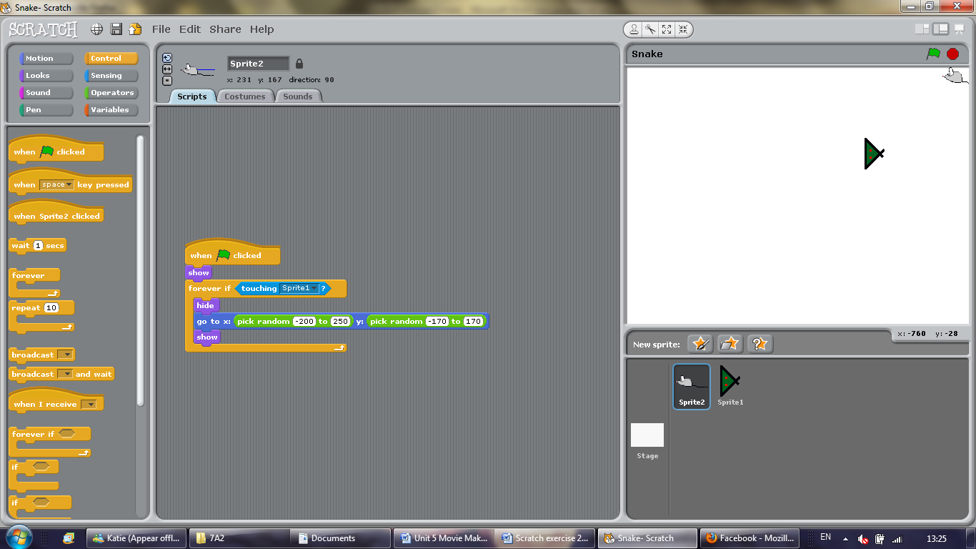You must create a consequence if the snake touches the mouse. This sequence identifies whether the snake has touched the mouse. If it has, it will hide go to a random co-ordinate on the stage, and appear again.

**Step 4:** Draw the snake a tail. If it touches its own tail – game over

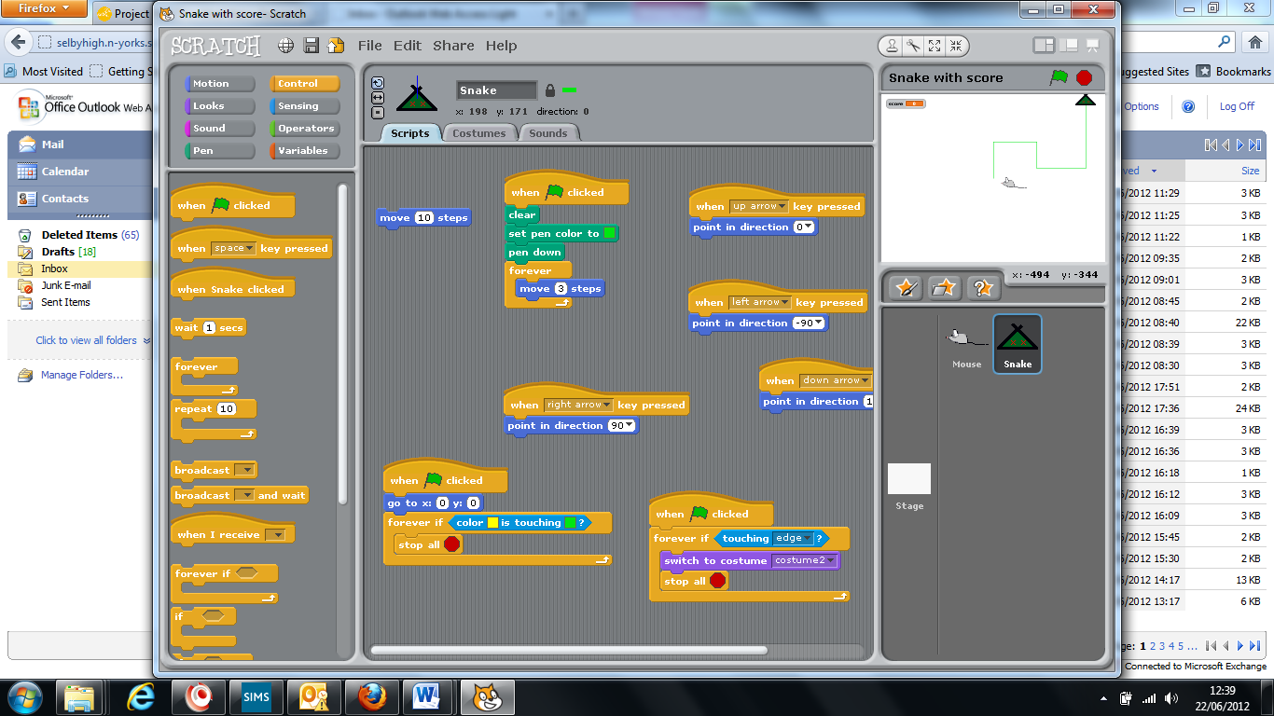You already have most of this script on the mouse.

On the PEN menu enter the additional commands.

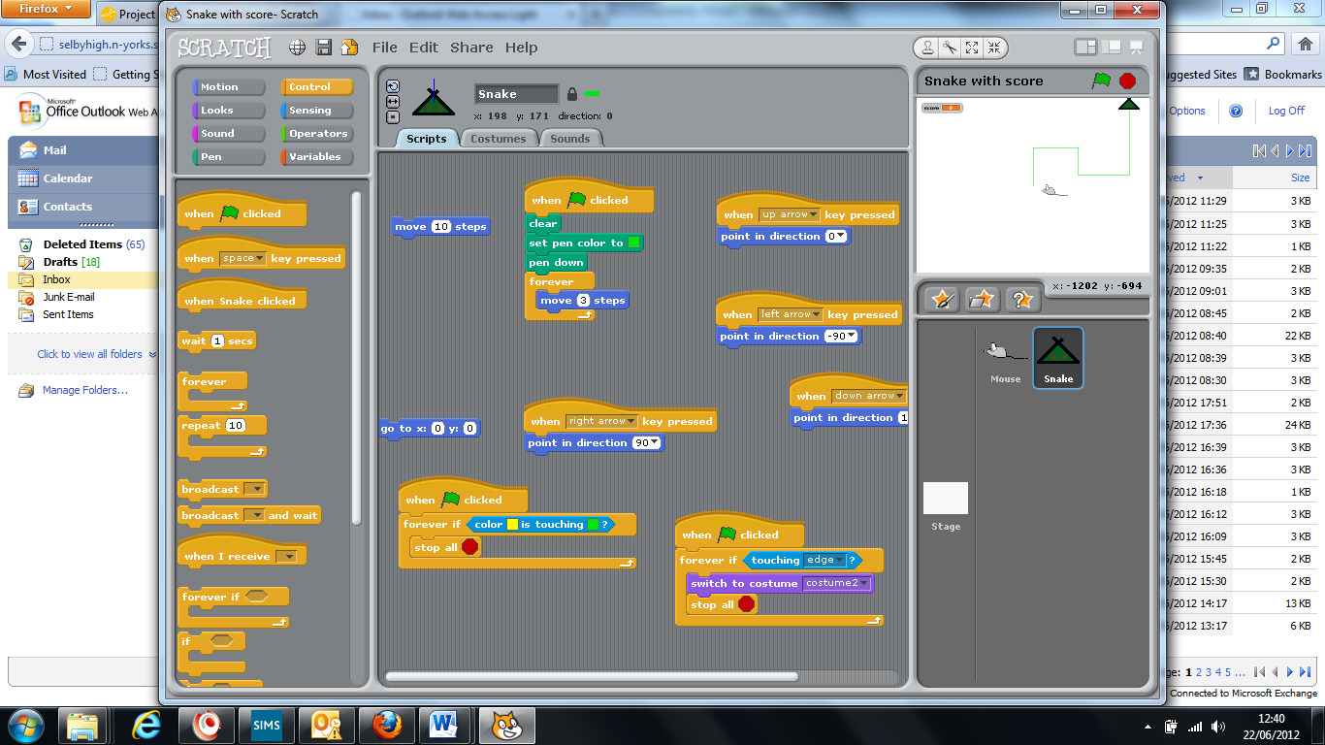This will clear the stage to begin with, set the pen colour to green and put the pen down so that when the snake moves it will draw a line

You will need to make this script from scratch.

It senses if the yellow colour (the sensor you drew on the snake) is touching the green colour (the line it is drawing) and stops the game if it does

*Tip: Make sure that you have the EXACT colour of the line and the sensor you have drawn.*

**Extension Tasks**

You can create a more complex game by doing the following things

* Make the snake always start from the middle
* Make the snake lose if it touches the edge
* Add different costumes so it will change when the game ends
* You can create a score card to keep track of how many mice you eat. You will need to create a variable called Score.
* You can create a series of costumes for the snake, each with increasing tail length. When the mouse gets eaten the tail will grow.